Box Office Predictions Using Data Collected from Twitter
Colt Wrobel  University of Alabama  cewrobel@crimson.ua.edu | Logan Skinner  University of Alabama  laskinner@crimson.ua.edu
Shawn Mitchell
University of Alabama
smmitchell2@crimson.ua.edu

ABSTRACT
The purpose of this paper is to discuss the method and findings of our research project for CS491: Social Media Analytics. In short, our goal was to determine if there is a reasonable metric for predicting a movie’s success based on Twitter traffic prior to launch. We measured a movie’s success based off several factors such as IMDB rating, Rotten Tomatoes rating, box office earnings, and the difference between box office earnings and movie budget. We found correlations between several factors.

Keywords
Movies, Twitter, predictions, box office.

INTRODUCTION

Movies are an incredibly popular pop culture item that bring in millions, sometimes billions, of dollars per title, with production budgets often in the hundreds of millions. With so much money flowing through the film industry, it is useful to be able to analyze public reactions and interest in films. This is where the motivation for our project lies.

Micro blogging applications such as Twitter have changed the landscape of data mining. Twitter allows us to use people as sensors for current events and public reactions. This project aims to use sentiment analysis of Twitter data to predict movie ratings, box office earnings, and compare public reactions to critic movie scores. Unlike ratings on sites such as IMDB or Rotten Tomatoes, Twitter data will allow us to rate movies based public sentiment rather than a positive or negative score. Using this data, we will be able to gauge excitement around a title and predict useful data about how it will perform prior to release and provide rating based on sentiment analysis after release. We will then be able to compare this data to critic ratings to see if they align or not.

Overtime, the ability to predict earnings will improve as more data is gathered, but at first it will be based on historical analysis. Using machine learning, we will be able to predict ratings as well with increasing accuracy.

RELATED WORK
Chuan Sun at the NYC Data Science Academy performed a similar study involving box office predictions. His study involved several factors, including data gathered from Facebook. Specifically, he looked for a correlation between the IMDB rating, a movie’s Facebook popularity, the movie’s top 3 actors’ Facebook popularity, and the movie’s director’s Facebook popularity. Popularity was determined by the number of likes a Facebook page has. Sun found a strong correlation between IMDB rating and the Facebook popularity of the movie and its actors. There was a small, but positive correlation with the popularity of the movie’s director, indicating that a director may be popular, but it does not necessarily mean all their movie’s will be successful. Sun found an interesting correlation between a movie’s duration and the IMDB rating, concluding that a longer movie tends to be higher rated.

METHOD
As previously mentioned, we focused on gathering historical data from previously released movies. This allowed us to accurately analyze people’s sentiments versus already well-established post-launch ratings. Due to time constraints and the amount of time it took to gather a movie’s data, we focused our research on 15 movies. We used three tools in our study: Twitter Application Programming Interface (API), Twitter Scraper, and Textblob.
The Twitter API is a publicly-released API for Twitter developers that allows users to gather and manipulate Twitter data easily. The API, paired with the Twitter Scraper tool, allowed us to query and gather tweets, retweets, and replies that involved a movie’s name. We gathered thousands upon thousands of tweets on each movie for our evaluation.
Textblob is an open-sourced Python library for processing text. We used Textblob for the sentiment analysis portion of our evaluation. It is a simple library that only requires a portion of text to be entered, and it returns a polarity factor. The polarity factor enabled us to easily gather the sentiment of each tweet. The polarity factor is a range from -1.0 to 1.0, with -1.0 being extremely negative and 1.0 being extremely positive. Factors near or exactly 0 are neutral.
We wrote 3 programs to gather data for our analysis. The first program was used to retrieve tweets. It is a simple program that takes a movie title and a date range, and then gathers all tweets involving said title within that date range and stores it in a JSON. We focused our date range to one week prior to a movie’s debut. For the keywords in our query, we used the movie title with spaces and without spaces, so the program would not miss hashtags. We used the Twitter Scraper tool for this program. For some movies, we retrieved hundreds of thousands of tweets. Our second program was used to count the total number of likes, retweets, and replies each tweet received, which allowed us to generate a number to give the total amount of attention a movie received. The Twitter API allowed us to easily complete this task. The third program was used to calculate sentiment for each tweet. Each movie’s JSON file containing their tweets were imported, and for each tweet, we ran it through Textblob to gather a polarity factor. This allowed us to calculate a total number of positive, negative, and neutral tweets for each movie. Below is a table containing all the raw data we gathered using the three programs.

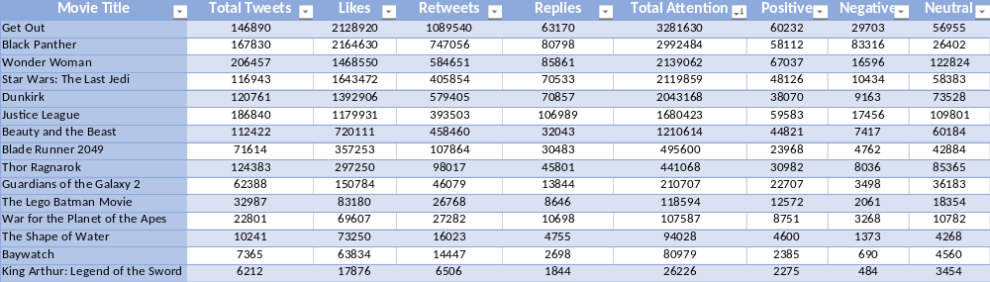
Table 1. Raw data gathered after running all 3 programs.

EVALUATION
With all necessary data gathered, we were able to start our evaluation and analysis. The table below contains some starting data for evaluation.

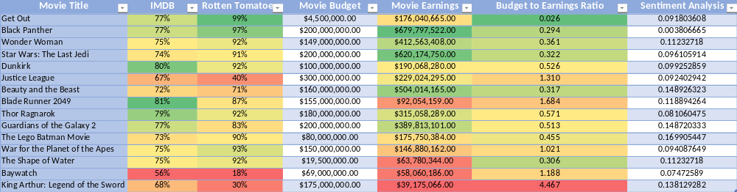
Table 2. Starting data for evaluation.

The rating and budget information was found on each movie’s Google page. The sentiment analysis column was found by averaging the polarity factors for every tweet on a movie. The budget to earnings ratio is color-coordinated for a visually-appealing way of showing successful/unsuccessful movies. This ratio is better suited to show a movie’s financial success versus just looking at a movie’s earnings.
The first correlation we will look at is a movie’s earnings vs. total attention on Twitter. As a reminder, total attention is the sum of tweets, retweets, likes, and replies. The following graph is a visual representation of the correlation.

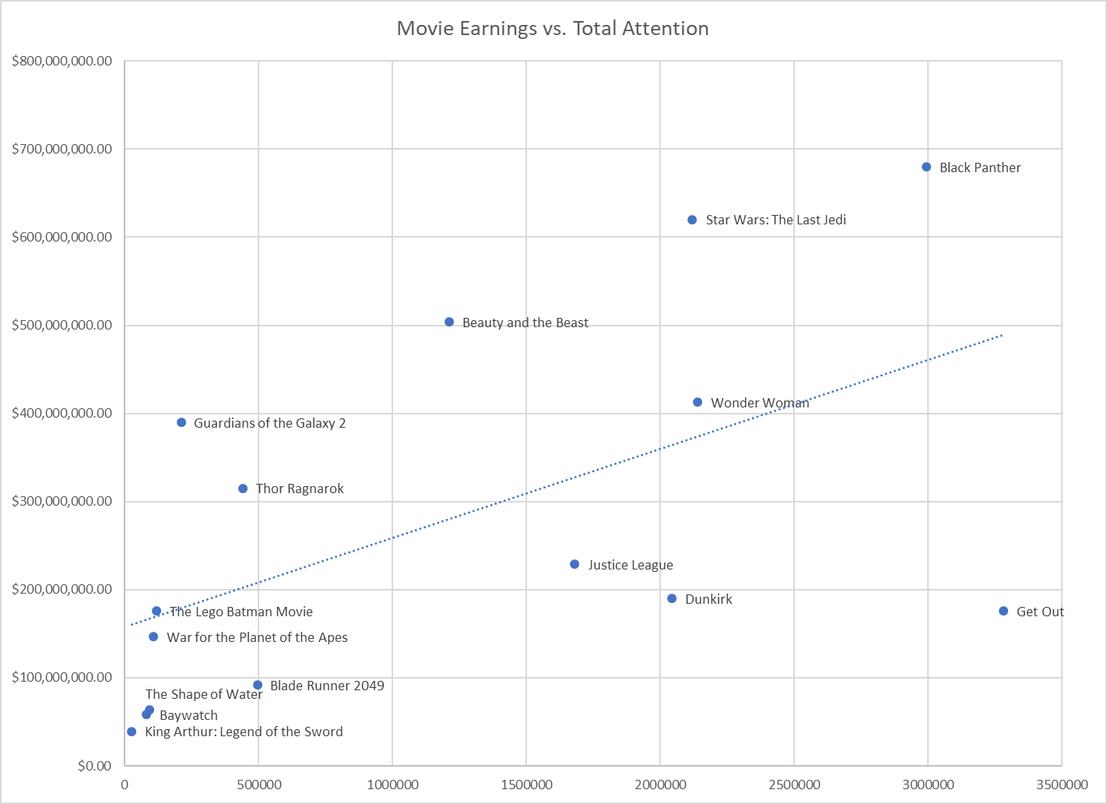
Figure 1. Movie Earnings vs Total Attention.

The trend line confirms that there is a strong correlation between a movie’s earnings and total attention on Twitter. Movies like King Arthur: Legend of the Sword and Black Panther strengthen the correlation, while Guardians of the Galaxy 2 and Get Out are outliers. Get Out being the most talked about movie while not even surpassing Dunkirk in earnings is easy to explain if you were around during its promotion and release. Get Out was a polarizing movie, eliciting strong feelings from different groups of people. People either expressed their strong feelings of excitement for seeing the movie or lack thereof, resulting in a large amount of people talking about it, but only less than half of those people going to see the movie.
Before we look at the next correlation, let’s discuss the Rotten Tomatoes score system. Unlike many other rating systems, Rotten Tomatoes does not use a typical 5 or 10-star system. It has its own system, called the Tomatometer. Only critic reviews can affect this meter. Instead of choosing several stars, critics choose between two options, rotten or fresh. These are added and averaged, giving you a percentage on the Tomatometer. Movies above 60% are considered fresh, while movies below are considered rotten. With that in mind, let’s look at the next graph.

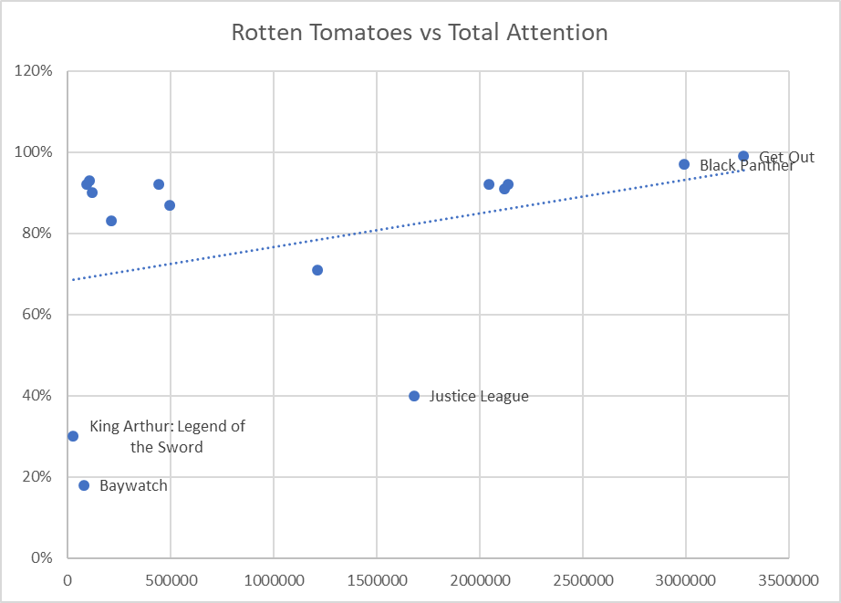
Figure 2. Rotten Tomatoes vs Total Attention.

The above graph represents the correlation between a movie’s Rotten Tomatoes score vs total attention on Twitter. Here we can see a very slightly positive correlation, with it leaning more neutral. This is one correlation we believe can be strengthened more towards being completely neutral if we had a much bigger sampling size. There are many movies, often termed Oscar-bait, that are lesser known among the public, but are huge hits with the critics. These movies would have high scores, but low attention, leveling out the trendline, resulting in a more neutral correlation. We chose to show the Rotten Tomatoes vs total attention over IMDB vs total attention because Rotten Tomato scores are only influenced by professional movie critics, which we believe is more indicative of how good a movie is. Let’s look at the next correlation, which gauges a movie’s success based off financial success.
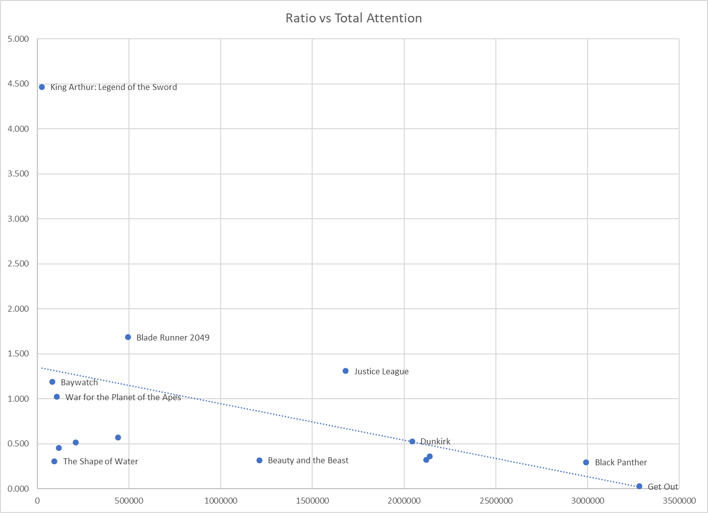
Figure 3. Ratio vs Total Attention.

The above graph shows the correlation between the earnings vs budget ratio and total attention on Twitter. We see there is a negative correlation, which makes sense. A lower ratio proves a movie made a fantastic return financially. This is a visual representation of how well Get Out and Black Panther did, versus the huge flop that was King Arthur: Legend of the Sword. The graph is self-explanatory, showing that total attention has a huge impact on the ratio. This graph is similar to movie earnings vs total attention, proving that the more people talk about a movie, the higher chance they will go see it. The difference is this graph is indicative of financial success, since it takes a movie budget into consideration. Next, we will look at the sentiment analysis portion of our evaluation.

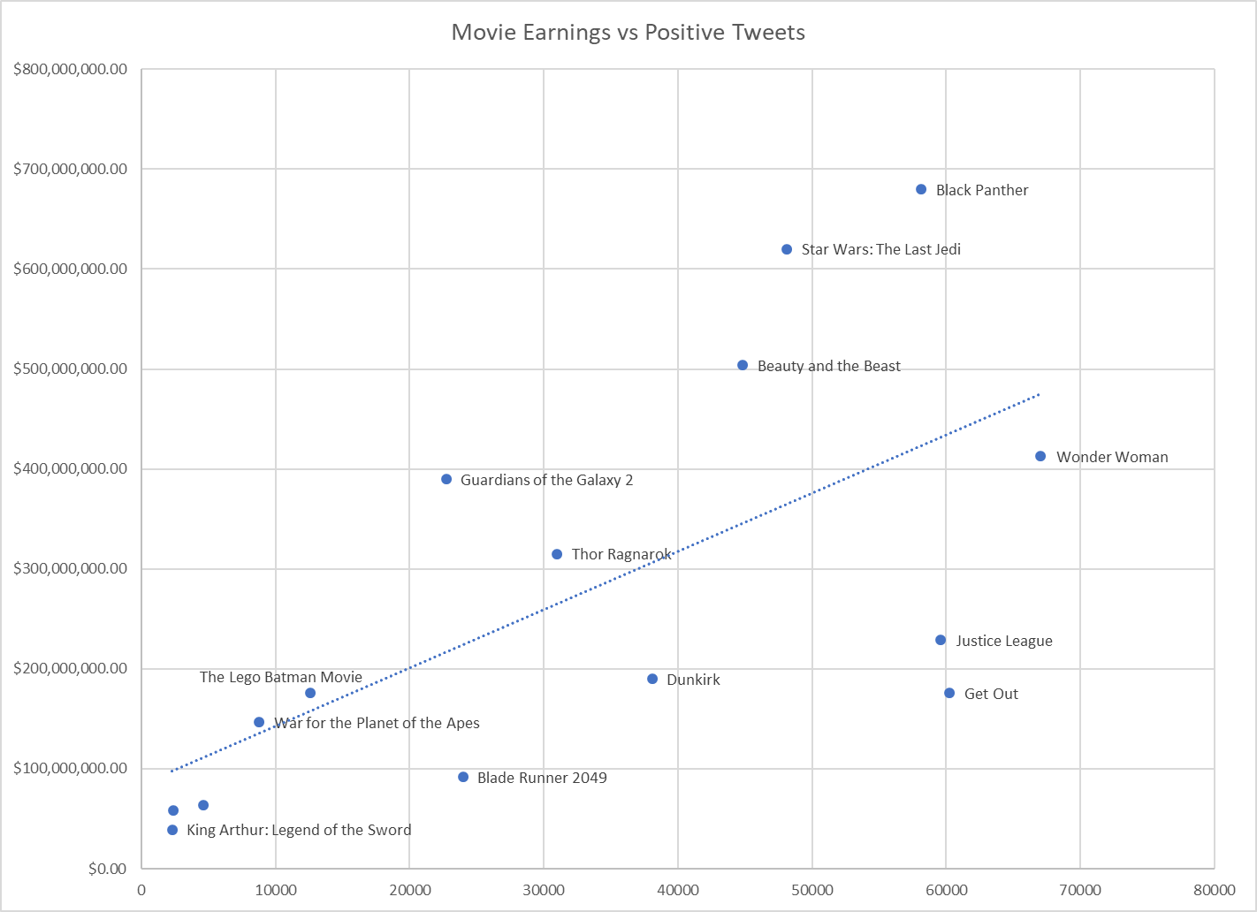
Figure 4. Movie Earnings vs Positive Tweets.

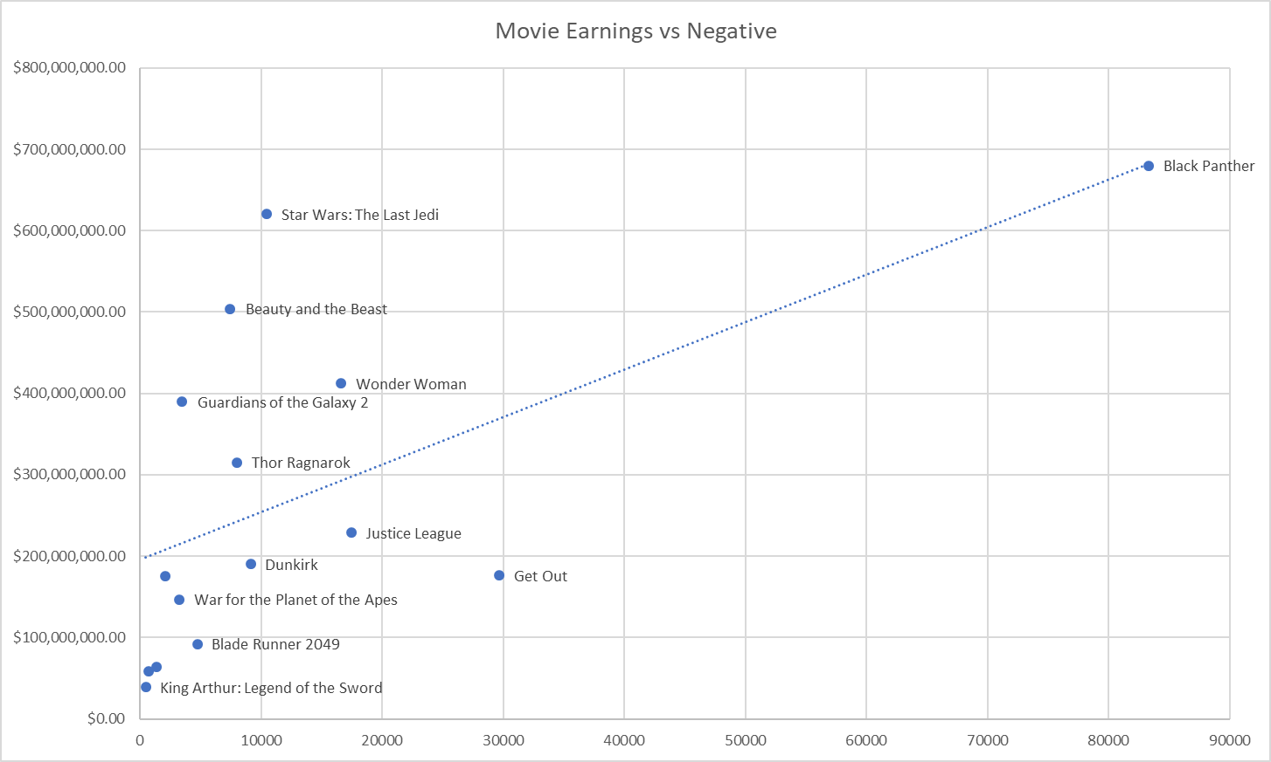
Figure 5. Movie Earnings vs Negative Tweets.

The above graphs show very strong correlation between movie earnings and positive/negative tweets. Positive and negative tweets were determined by their polarity factor retrieved from Textblob. The movies in the positive tweets graph are more spread out, while movies are positioned more to the left on the negative tweet graph. Together, these graphs prove how polarizing Black Panther was, yet it was still a huge hit. It is worth noting that a large portion of tweets were deemed neutral do to many people making general statements like “In less than 100 hours, I will be watching #WonderWoman.” A reason for this could be due to the fact we collected tweets a week prior to a movie’s launch, so people are just stating that they will be seeing the movie. This will be further discussed in the discussion section.

DISCUSSION
For our discussion portion of this paper, we will be considering several questions.

What about analyzing older movies?
We asked this question early on but decided not to include these in our sample for several reasons. With how current social media is, we believed we would not find sufficient data for older movies. For the little information we would find, we thought it would strew our results greatly. Of course, there are many older movies that were successful, in a financial and public opinion sense, but few people would be tweeting about them. An older movie could have huge box office earnings and a great critic’s score, but total attention would be low due to it being an older movie.

Is sentiment analysis necessary for predicting a movie’s success?
This is a question we could not answer until after our research. In most cases, the number of neutral tweets outweighed positive and negative tweets. We concluded that sentiment analysis on tweets one week prior to launch was inconclusive. Most people tweeting about a movie a week prior are simply saying they will go see the movie. We will mention this again in our conclusion portion.

What makes a movie “successful”?
We answered this question early by involving the two aspects that make a movie successful in our research. These two aspects are ratings success and financial success. We portrayed both and judged them against Twitter attention to get an accurate representation of a movie’s true success.

CONCLUSION

FURTHER IMPROVMENTS

REFERENCES
Sun, C. (2016) - Predict Movie Rating, NYC Data Science Academy Blog. https://nycdatascience.com/blog/student-works/web-scraping/movie-rating-prediction/

